MongoDB Query: use
BasketballDB
Explanation: Creates or switches to the BasketballDB database.

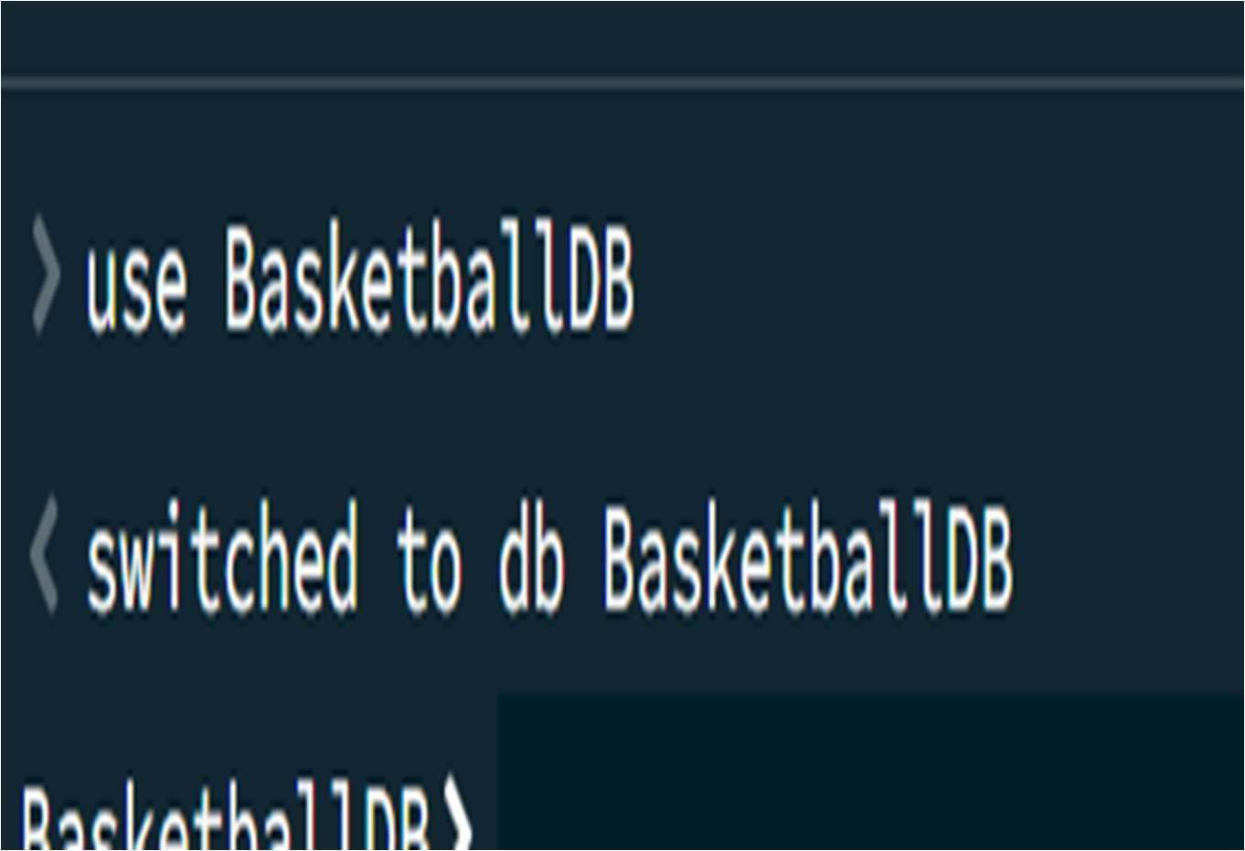

CREATE COLLECTION
MongoDB Query:
db.createCollection("matches")
Explanation: Creates a collection named matches.

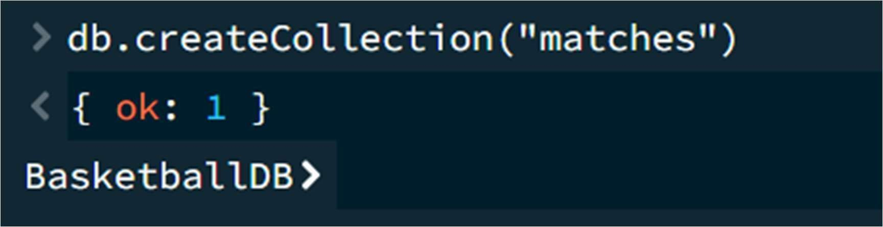

INSERT 50 BASKETBALL MATCH RECORDS
MongoDB Query:
db.matches.insertMany([
{matchId:1, team1:"India", team2:"Australia", team1Score:92, team2Score:87, venue:"New Delhi"},
{matchId:2, team1:"USA", team2:"Canada", team1Score:105, team2Score:98, venue:"Toronto"},
{matchId:3, team1:"Spain", team2:"France", team1Score:88, team2Score:91, venue:"Madrid"},
{matchId:4, team1:"Germany", team2:"Italy", team1Score:96, team2Score:82, venue:"Berlin"}, {matchId:5, team1:"India", team2:"Japan", team1Score:101, team2Score:95, venue:"Mumbai"},
{matchId:6, team1:"Brazil", team2:"Argentina", team1Score:89, team2Score:94, venue:"Rio de Janeiro"},
{matchId:7, team1:"Australia", team2:"China", team1Score:97, team2Score:84, venue:"Sydney"},
{matchId:8, team1:"France", team2:"Belgium", team1Score:91, team2Score:79, venue:"Paris"},
{matchId:9, team1:"USA", team2:"Mexico", team1Score:112, team2Score:89, venue:"Dallas"}, {matchId:10, team1:"Canada", team2:"Brazil", team1Score:86, team2Score:90, venue:"Vancouver"},

{matchId:11, team1:"India", team2:"China", team1Score:98, team2Score:93, venue:"Kolkata"}, {matchId:12, team1:"Japan", team2:"South Korea", team1Score:87, team2Score:82, venue:"Tokyo"},
{matchId:13, team1:"Spain", team2:"Germany", team1Score:94, team2Score:89, venue:"Barcelona"},
{matchId:14, team1:"Italy", team2:"Greece", team1Score:81, team2Score:88, venue:"Rome"},
{matchId:15, team1:"Australia", team2:"Japan", team1Score:103, team2Score:91, venue:"Melbourne"},
{matchId:16, team1:"Argentina", team2:"Chile", team1Score:95, team2Score:78, venue:"Buenos Aires"},
{matchId:17, team1:"USA", team2:"France", team1Score:108, team2Score:102, venue:"New York"},
{matchId:18, team1:"Canada", team2:"Spain", team1Score:90, team2Score:97, venue:"Montreal"},
{matchId:19, team1:"India", team2:"South Korea", team1Score:85, team2Score:80, venue:"Bengaluru"},
{matchId:20, team1:"Brazil", team2:"Uruguay", team1Score:92, team2Score:76, venue:"Sao Paulo"},

{matchId:21, team1:"Germany", team2:"France", team1Score:99, team2Score:101, venue:"Munich"},
{matchId:22, team1:"Australia", team2:"India", team1Score:94, team2Score:89, venue:"Sydney"},
{matchId:23, team1:"USA", team2:"Spain", team1Score:115, team2Score:108, venue:"Los Angeles"},
{matchId:24, team1:"Japan", team2:"China", team1Score:83, team2Score:96, venue:"Osaka"},
{matchId:25, team1:"Argentina", team2:"Brazil", team1Score:91, team2Score:87, venue:"Cordoba"},
{matchId:26, team1:"France", team2:"Italy", team1Score:104, team2Score:92, venue:"Lyon"},
{matchId:27, team1:"Canada", team2:"USA", team1Score:88, team2Score:109, venue:"Toronto"},
{matchId:28, team1:"India", team2:"Nepal", team1Score:110, team2Score:72, venue:"New Delhi"},
{matchId:29, team1:"Spain", team2:"Portugal", team1Score:93, team2Score:85, venue:"Madrid"},
{matchId:30, team1:"Germany", team2:"Netherlands", team1Score:87, team2Score:90, venue:"Hamburg"},

{matchId:31, team1:"Australia", team2:"New Zealand", team1Score:102, team2Score:96, venue:"Perth"},
{matchId:32, team1:"India", team2:"Sri Lanka", team1Score:99, team2Score:76, venue:"Chennai"},
{matchId:33, team1:"USA", team2:"Argentina", team1Score:118, team2Score:97, venue:"Chicago"},
{matchId:34, team1:"France", team2:"Spain", team1Score:86, team2Score:93, venue:"Paris"},
{matchId:35, team1:"Brazil", team2:"Colombia", team1Score:100, team2Score:84, venue:"Brasilia"},
{matchId:36, team1:"Japan", team2:"Philippines", team1Score:89, team2Score:94, venue:"Tokyo"},
{matchId:37, team1:"Germany", team2:"Belgium", team1Score:105, team2Score:88, venue:"Frankfurt"},
{matchId:38, team1:"Canada", team2:"Mexico", team1Score:96, team2Score:81, venue:"Vancouver"},
{matchId:39, team1:"India", team2:"Iran", team1Score:91, team2Score:86, venue:"Hyderabad"},
{matchId:40, team1:"Australia", team2:"South Korea", team1Score:108, team2Score:92, venue:"Melbourne"},

{matchId:41, team1:"USA", team2:"Germany", team1Score:111, team2Score:95, venue:"Boston"},
{matchId:42, team1:"Spain", team2:"Greece", team1Score:97, team2Score:89, venue:"Valencia"},
{matchId:43, team1:"India", team2:"Japan", team1Score:102, team2Score:88, venue:"Pune"},
{matchId:44, team1:"Brazil", team2:"Chile", team1Score:93, team2Score:79, venue:"Rio de Janeiro"},
{matchId:45, team1:"France", team2:"Germany", team1Score:100, team2Score:98, venue:"Marseille"},
{matchId:46, team1:"Australia", team2:"Philippines", team1Score:107, team2Score:99, venue:"Brisbane"},
{matchId:47, team1:"Canada", team2:"Argentina", team1Score:89, team2Score:92, venue:"Ottawa"},
{matchId:48, team1:"India", team2:"Australia", team1Score:106, team2Score:101, venue:"Ahmedabad"},
{matchId:49, team1:"USA", team2:"Canada", team1Score:120, team2Score:104, venue:"Las Vegas"},
{matchId:50, team1:"Spain", team2:"Italy", team1Score:98, team2Score:83, venue:"Seville"}
])
Explanation: Inserts 50 basketball match documents into the matches collection
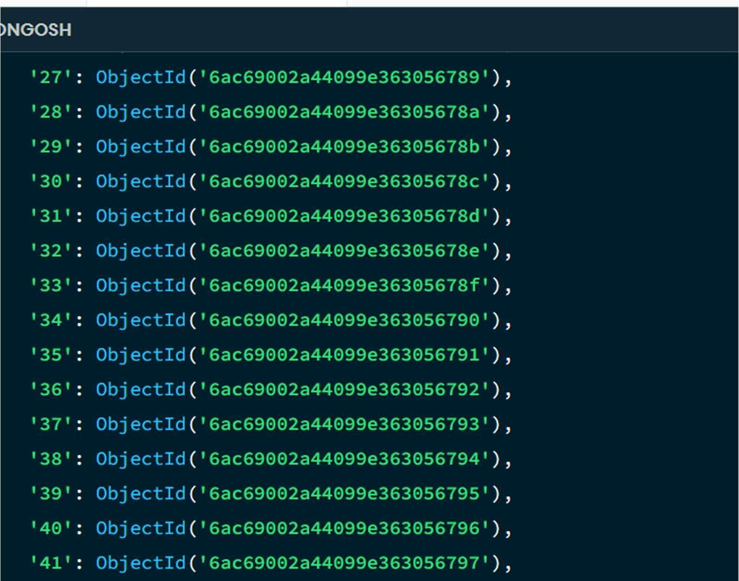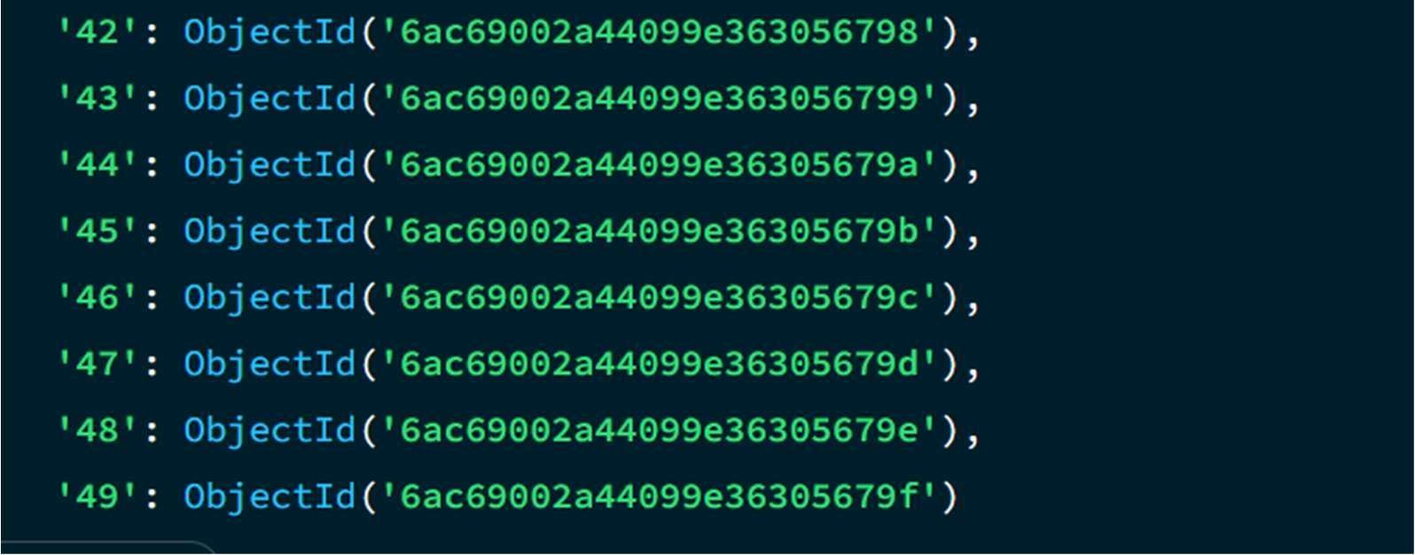

4. DISPLAY ALL PLAYERS
MongoDB Query:
db.matches.find()
Explanation: Retrieves all documents from the matches collection.
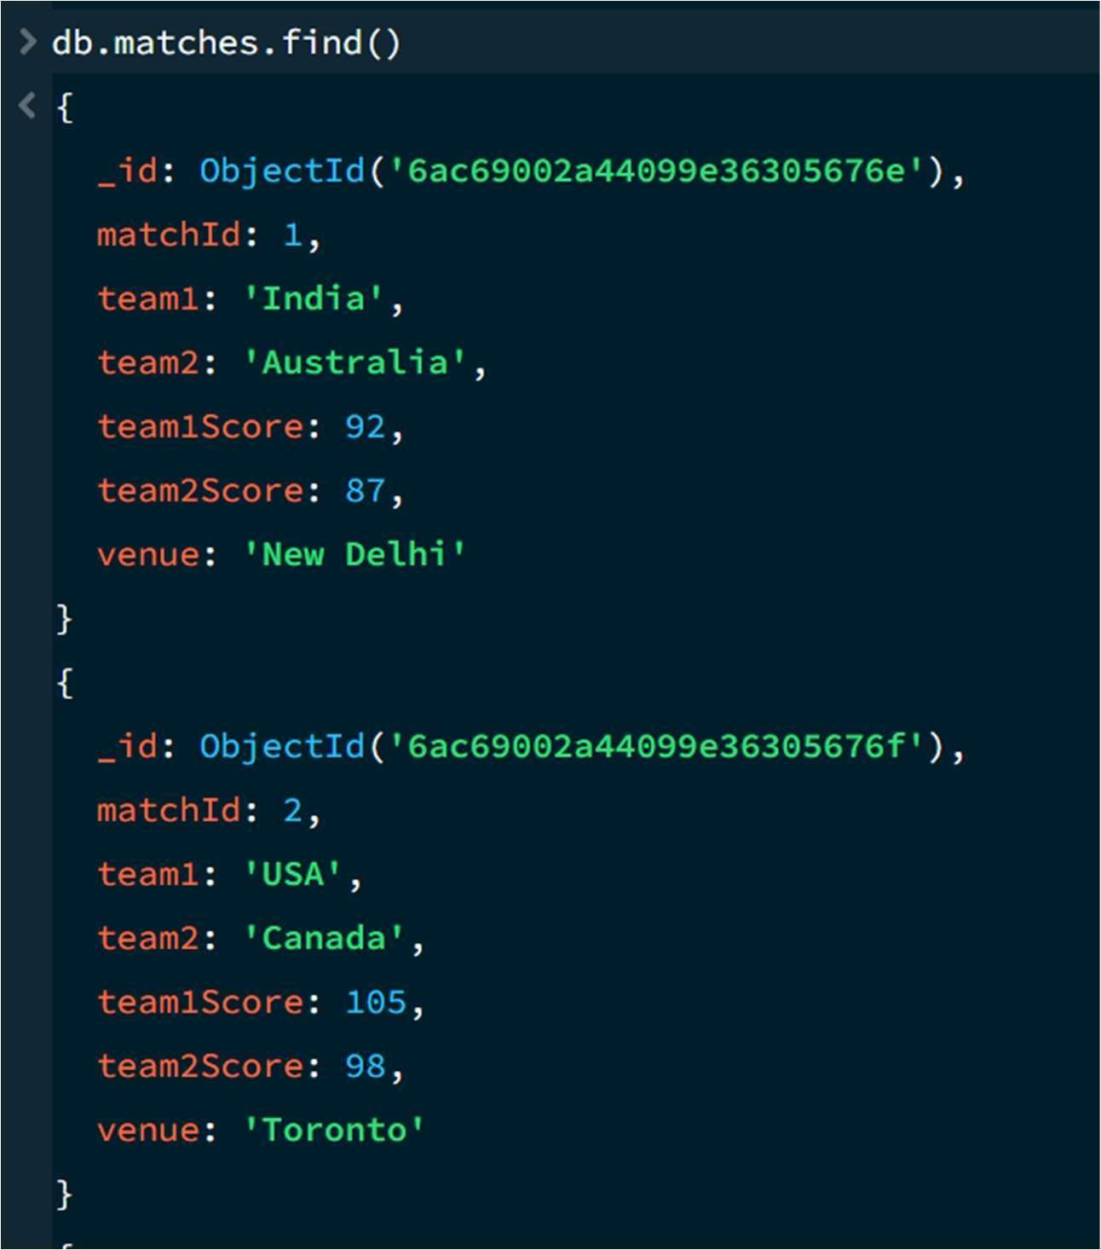

5. EQUAL TO — $eq
MongoDB Query:
db.matches.find({ team1Score:
{$eq: 92}
})
Explanation: Finds basketball matches where Team 1 scored exactly 92 points.
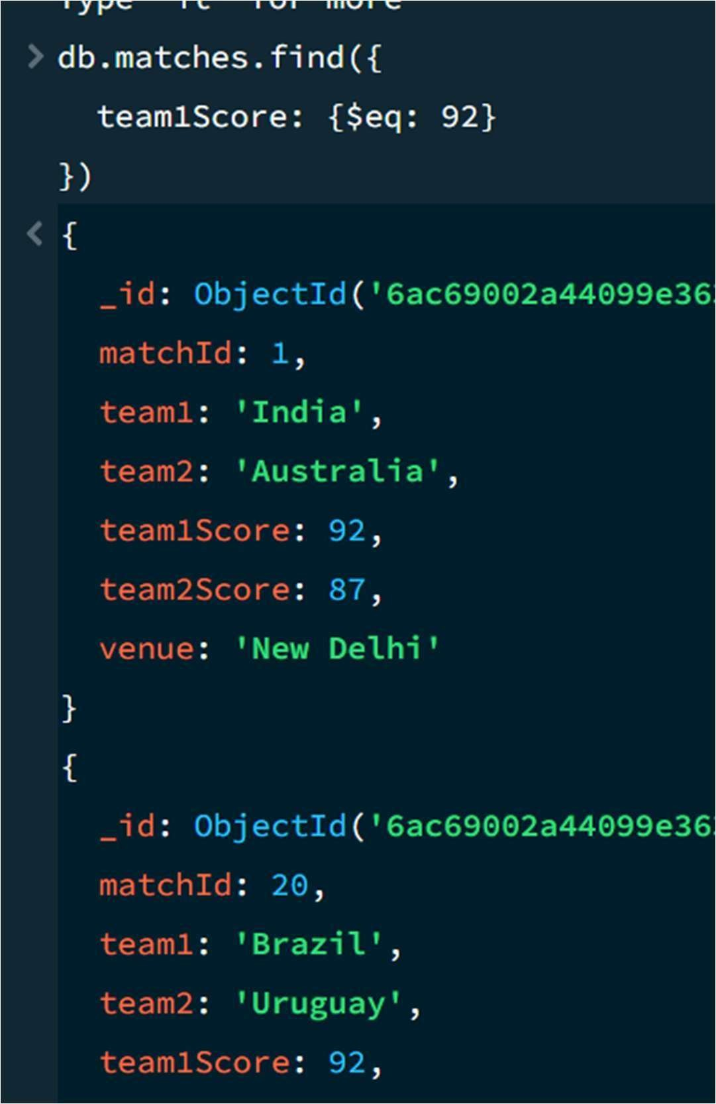

6. GREATER THAN — $gt
MongoDB Query:
db.matches.find({ team1Score:
{$gt: 100}
})
Explanation: Finds basketball matches where Team 1 scored more than 100 points.
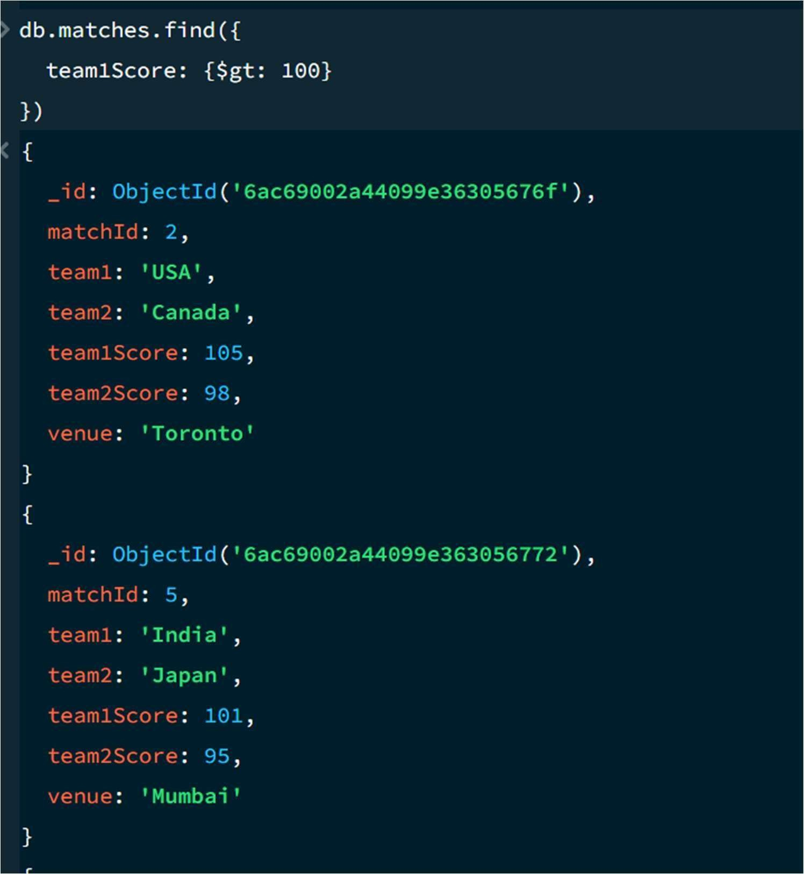

7. LESS THAN — $lt
MongoDB Query: db.matches.find({ team1Score: {$lt: 90}
})
Explanation: Finds basketball matches where Team 1 scored less than 90 points.
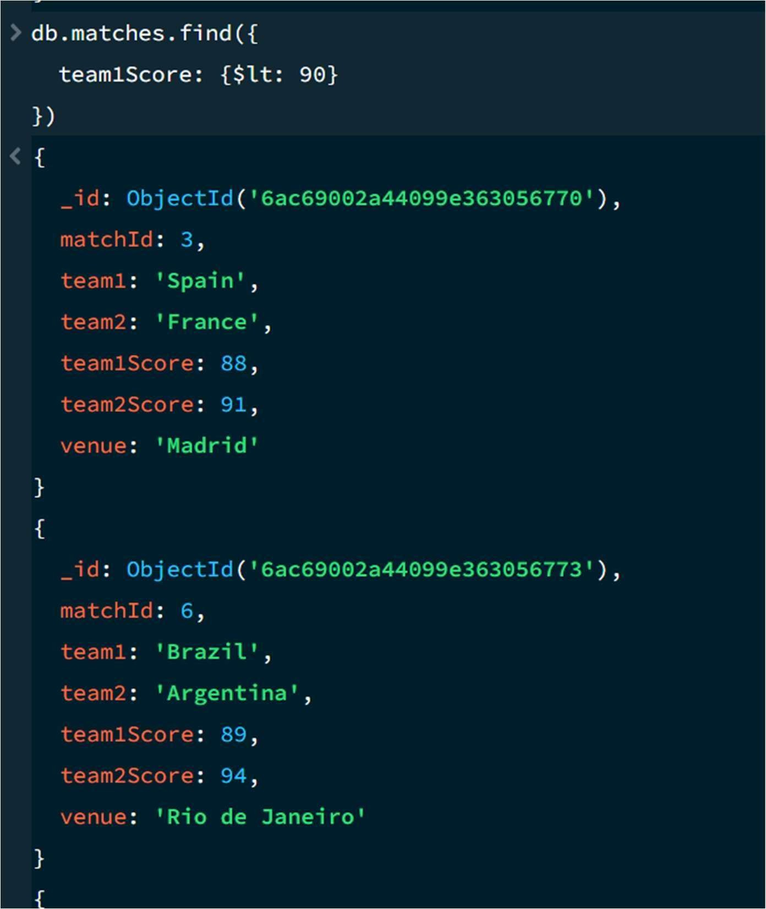

GREATER THAN OR EQUAL TO — $gte MongoDB Query: db.matches.find({ team1Score: {$gte: 100} })
Explanation: Finds basketball matches where Team 1 scored 100 or more points.
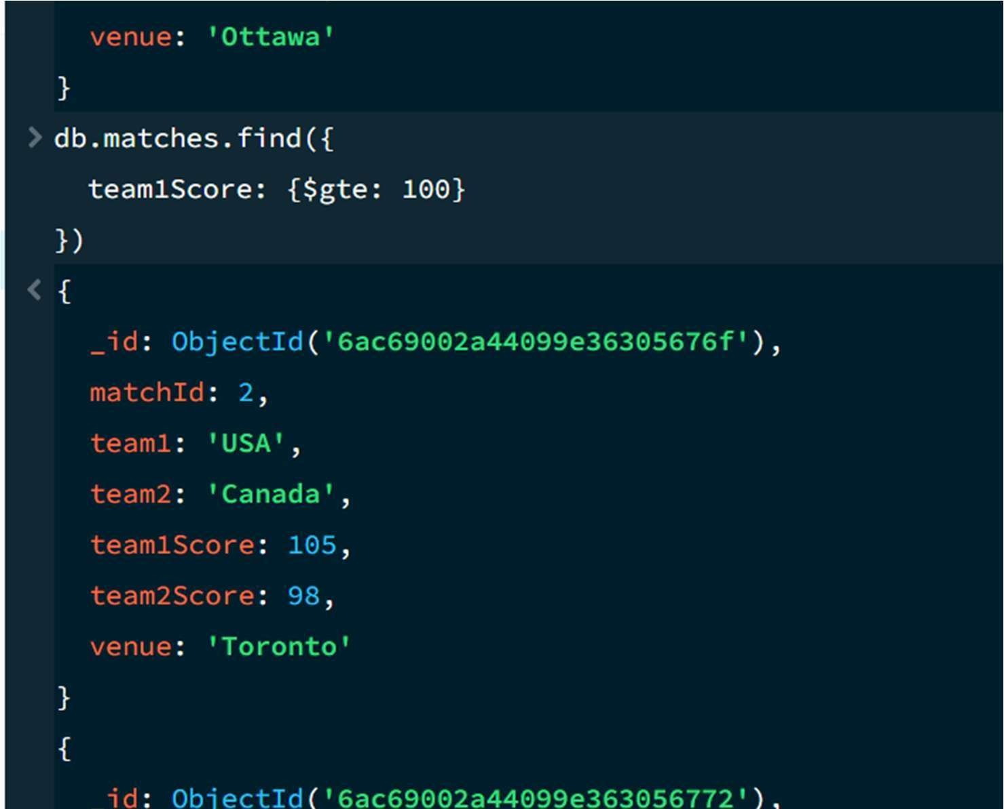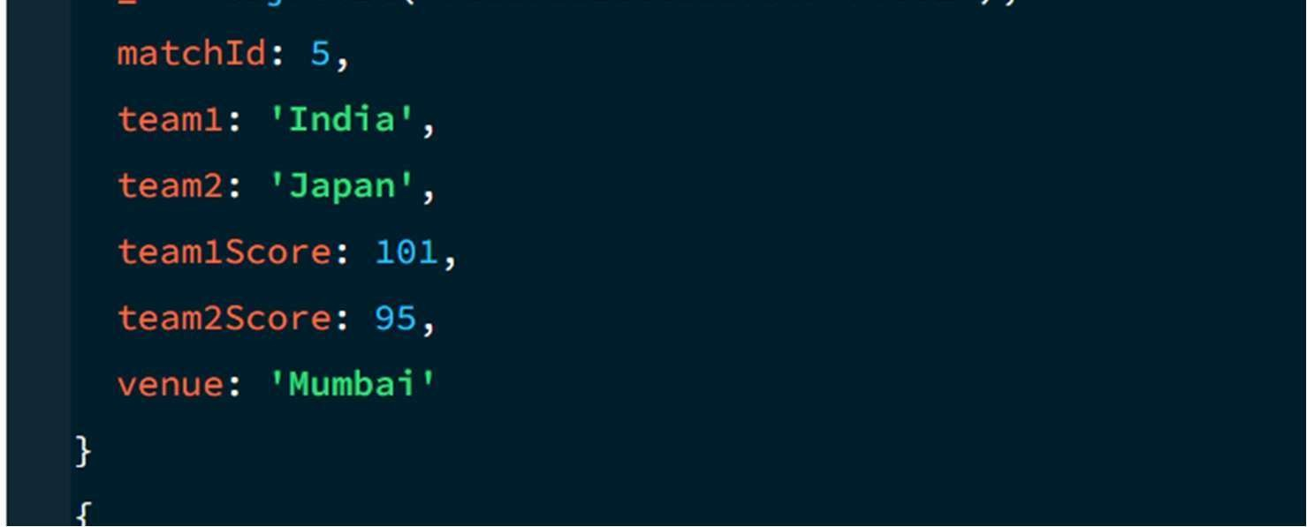

LESS THAN OR EQUAL TO — $lte
MongoDB Query: db.matches.find({ team1Score: {$lte: 90}
})
Explanation: Finds basketball matches where Team 1 scored 90 or fewer points.
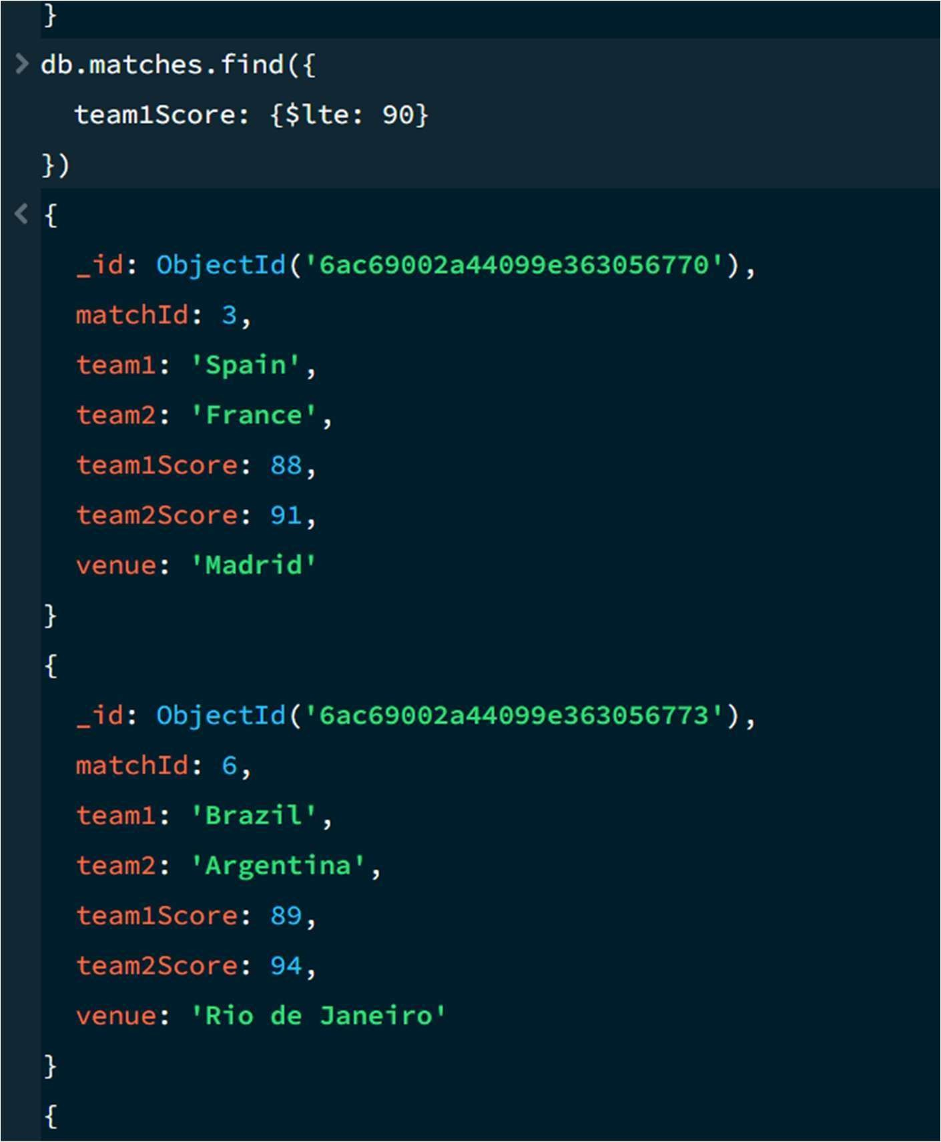

UPDATE OPERATION

MongoDB Query: db.matches.updateOne(
{matchId:5},
{$set:{team1Score:105}}
)
Explanation: Updates the Team 1 score to 105 for the match with matchId 5.
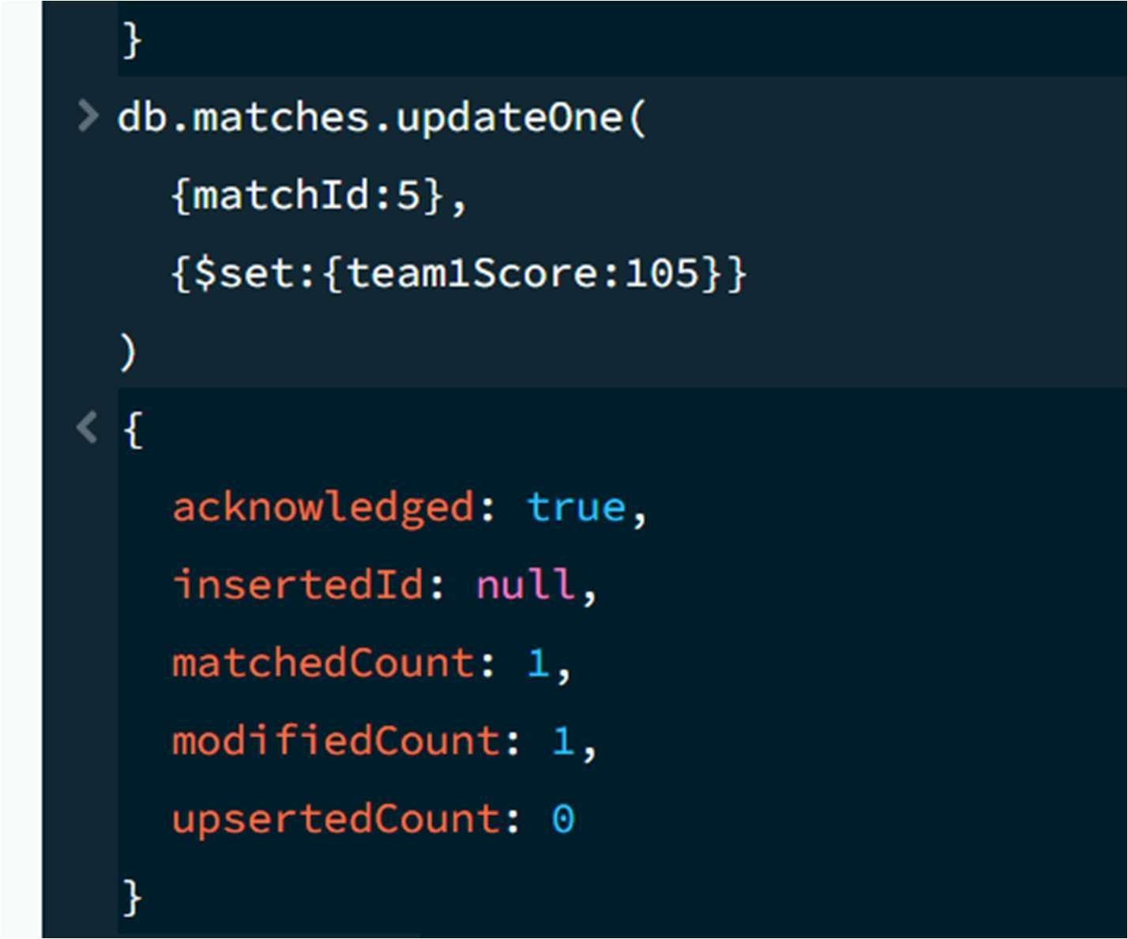

DELETE ONE OPERATION
MongoDB Query:
db.matches.deleteOne({ matchId:10
})

Explanation: Deletes one document matching matchId 10.
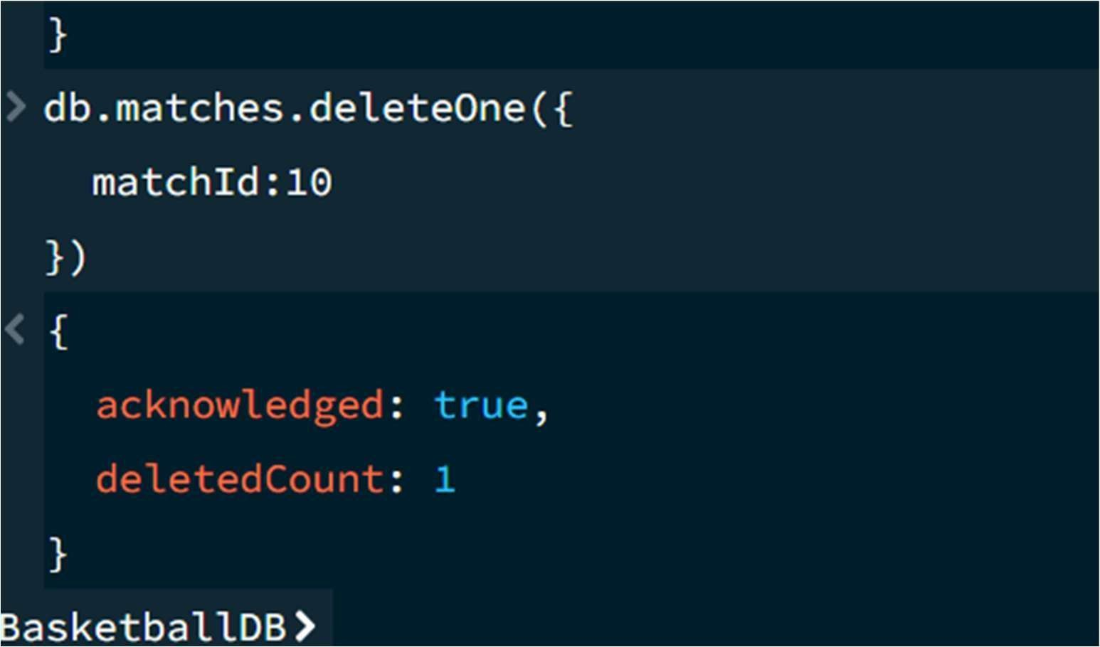

DELETE MANY OPERATION
MongoDB Query:
db.matches.deleteMany({ team1Score: {$lt:90}
})
Explanation: Deletes all basketball matches where Team 1 scored below 90 points.

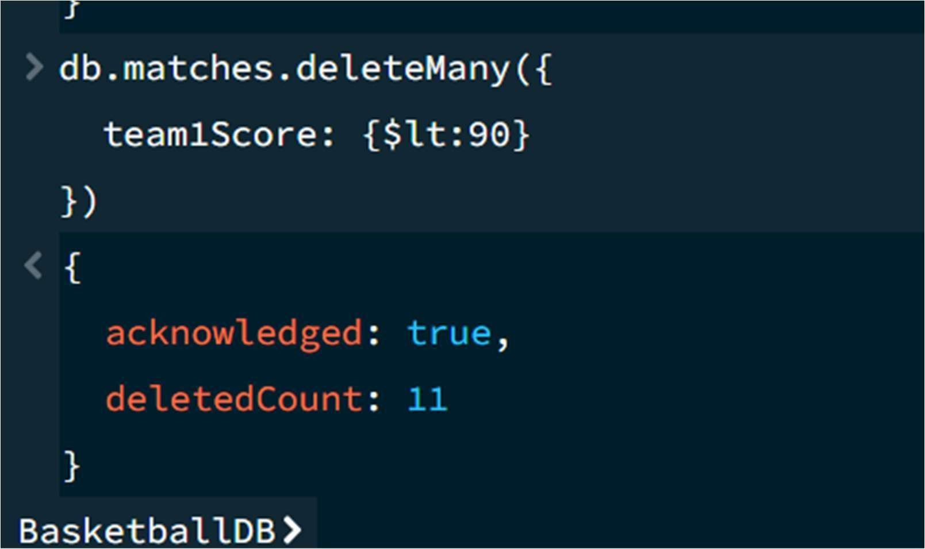

13. AND OPERATION — $and
MongoDB Query: db.matches.find({
$and:[
{team1Score:{$gt:100}},
{team1:"India"}
]
})
Explanation: Finds matches satisfying both conditions: Team 1 is India and Team 1 scored more than 100 points.
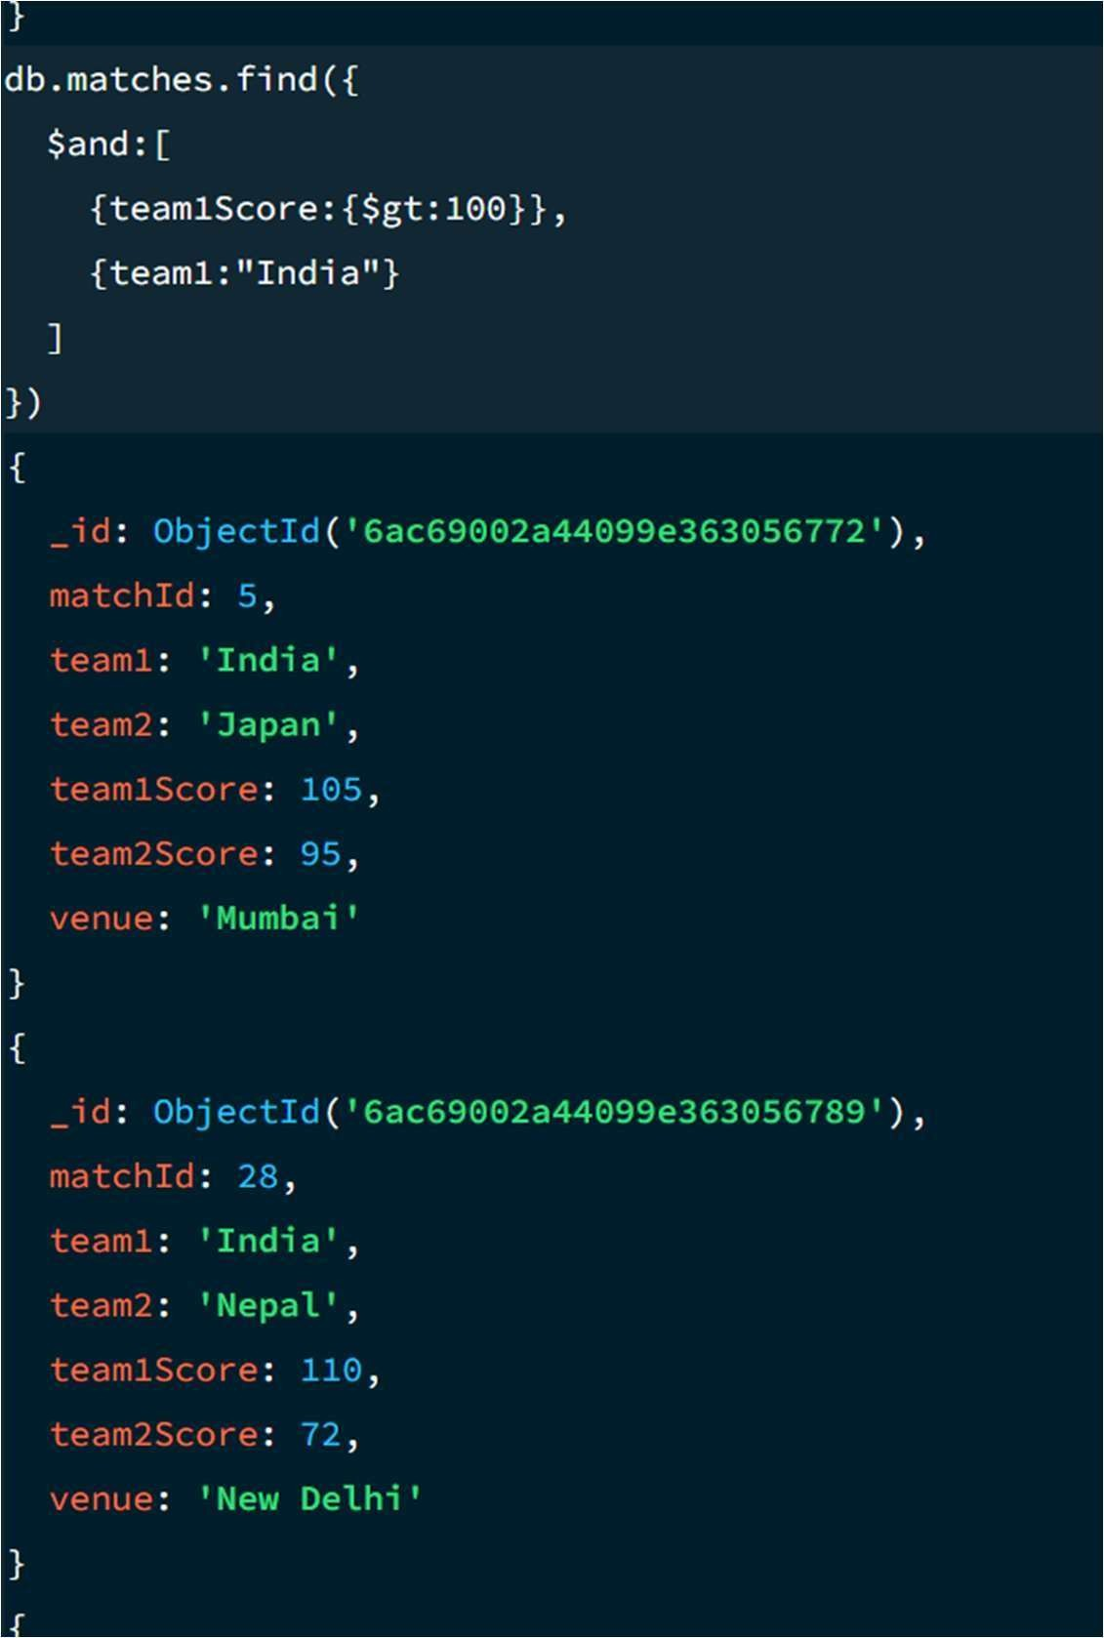

14. OR OPERATION — $or
MongoDB Query: db.matches.find({
$or:[
{team1:"India"},
{team1:"USA"}
]
})
Explanation: Finds basketball matches where either India or USA is Team 1.
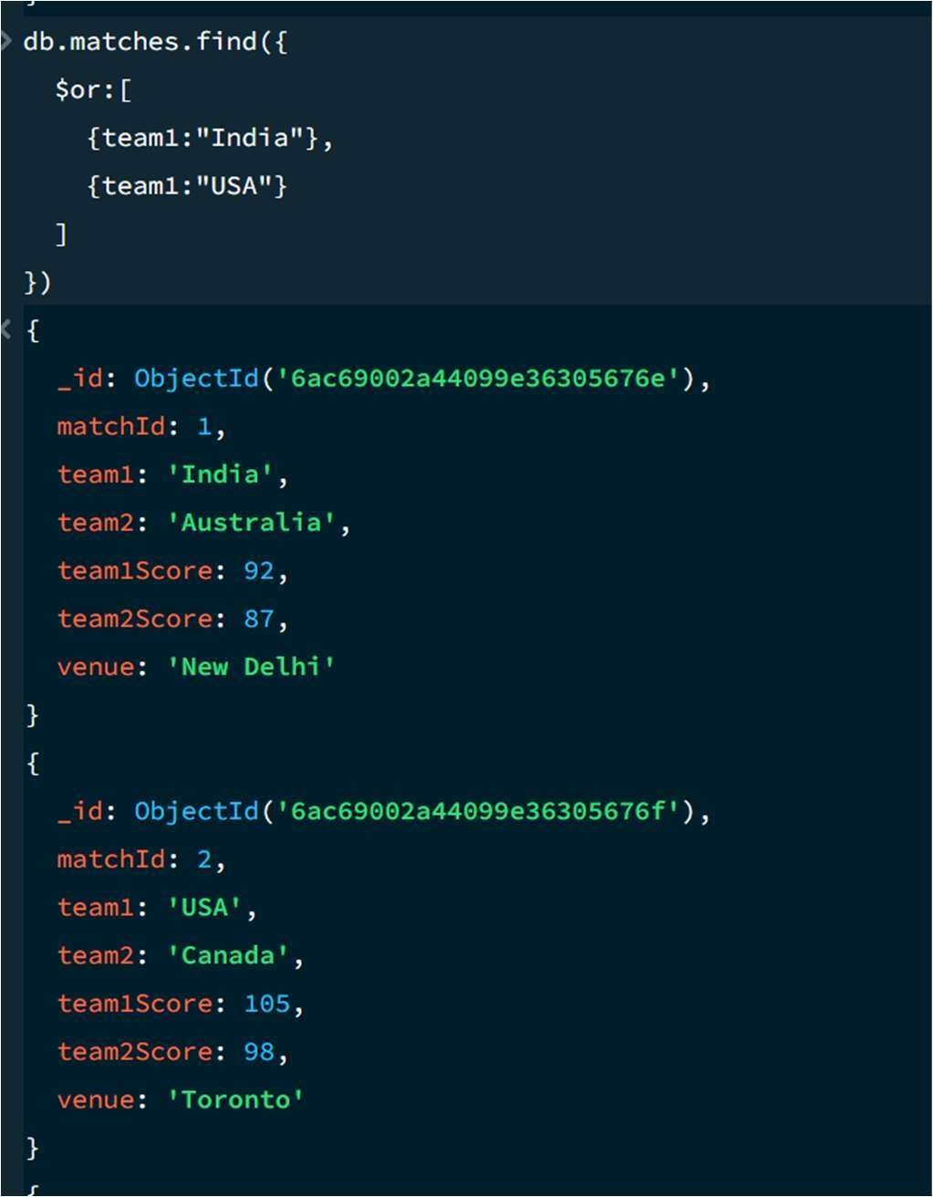

15. SORT OPERATION
- Ascending Order MongoDB Query:
db.matches.find().sort({ team1Score: 1
})
Explanation: Sorts matches by Team 1's score from lowest to highest. Use 1 for ascending order.
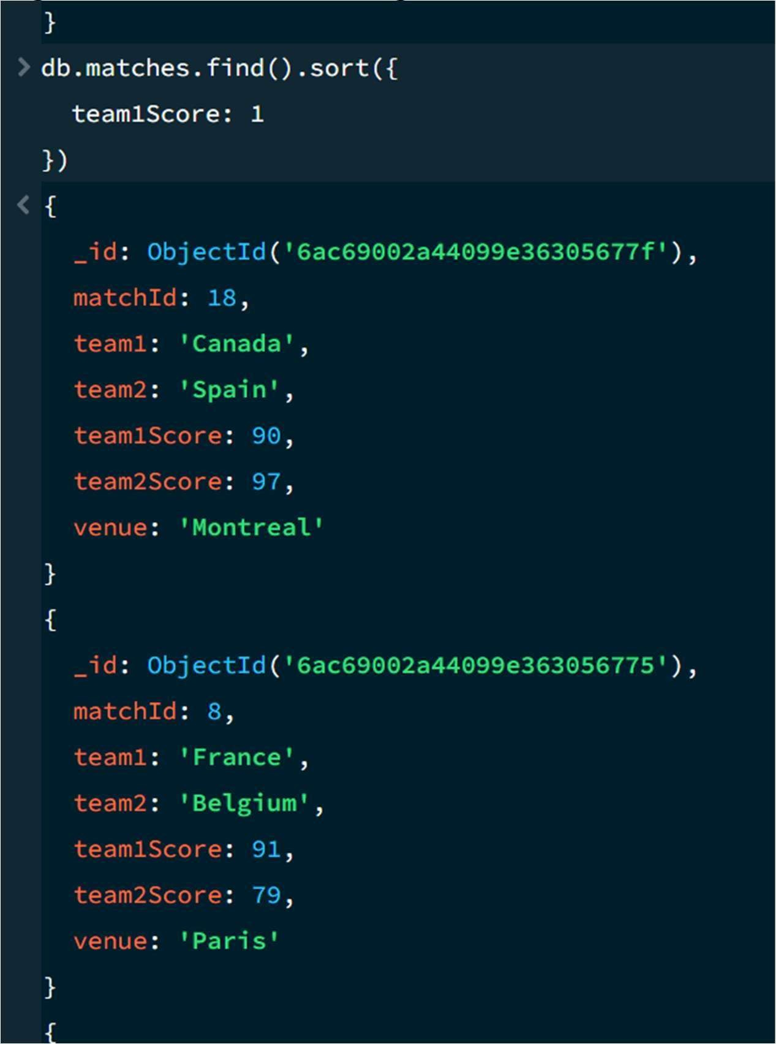

- Descending Order MongoDB Query:
db.matches.find().sort({ team1Score: -1
})
Explanation: Sorts matches by Team 1's score from highest to lowest. Use -1 for descending order.
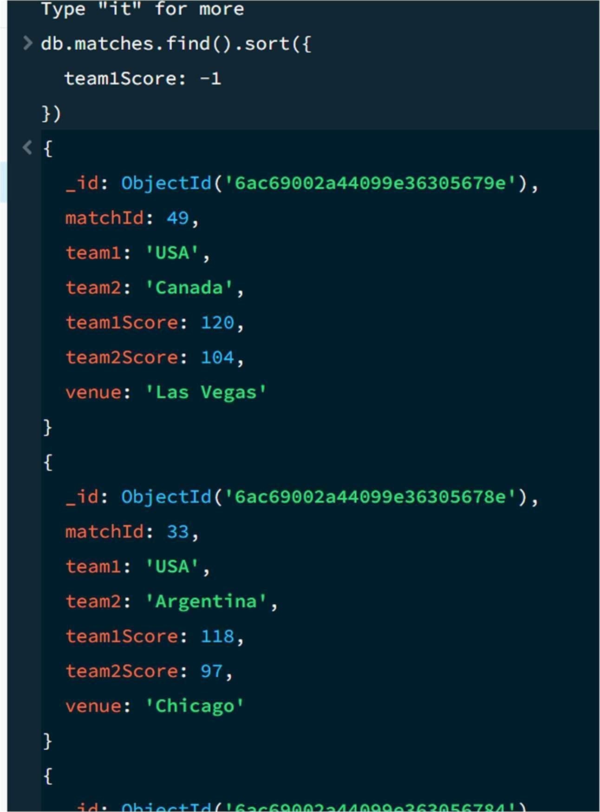

17. SEARCH BY TEAM MongoDB Query:

db.matches.find({ team1:"India" })
Explanation: Finds all basketball matches where India is Team 1.
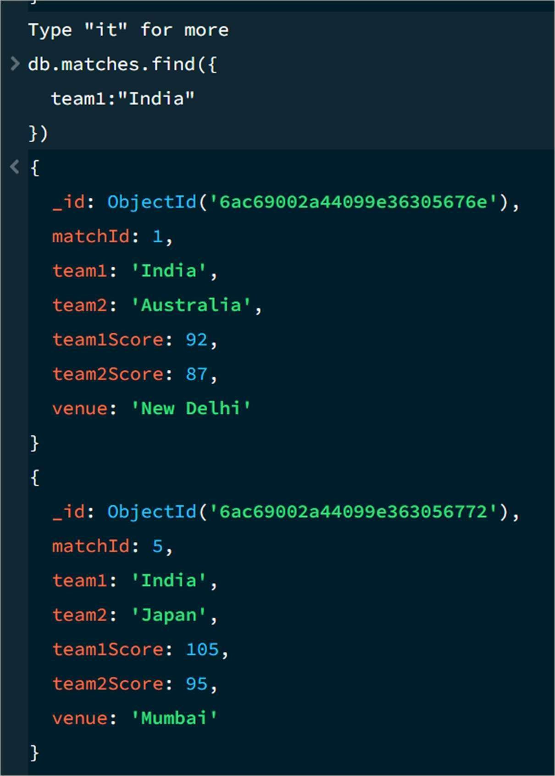

18. COUNT DOCUMENTS MongoDB
Query:
db.matches.countDocuments()
Explanation: Counts the documents currently present in the collection after the delete operations.

